Name: Madireddy Mahesh

Batch : March 1st 2022

Tutor : Raham Shaik

Project Name : Integration with Jenkins

* Integration of Maven with Jenkins:

1. Create 2 Ec2 instances
2. In one instance configure Jenkins
3. In another instance configure jfrog Artifactory

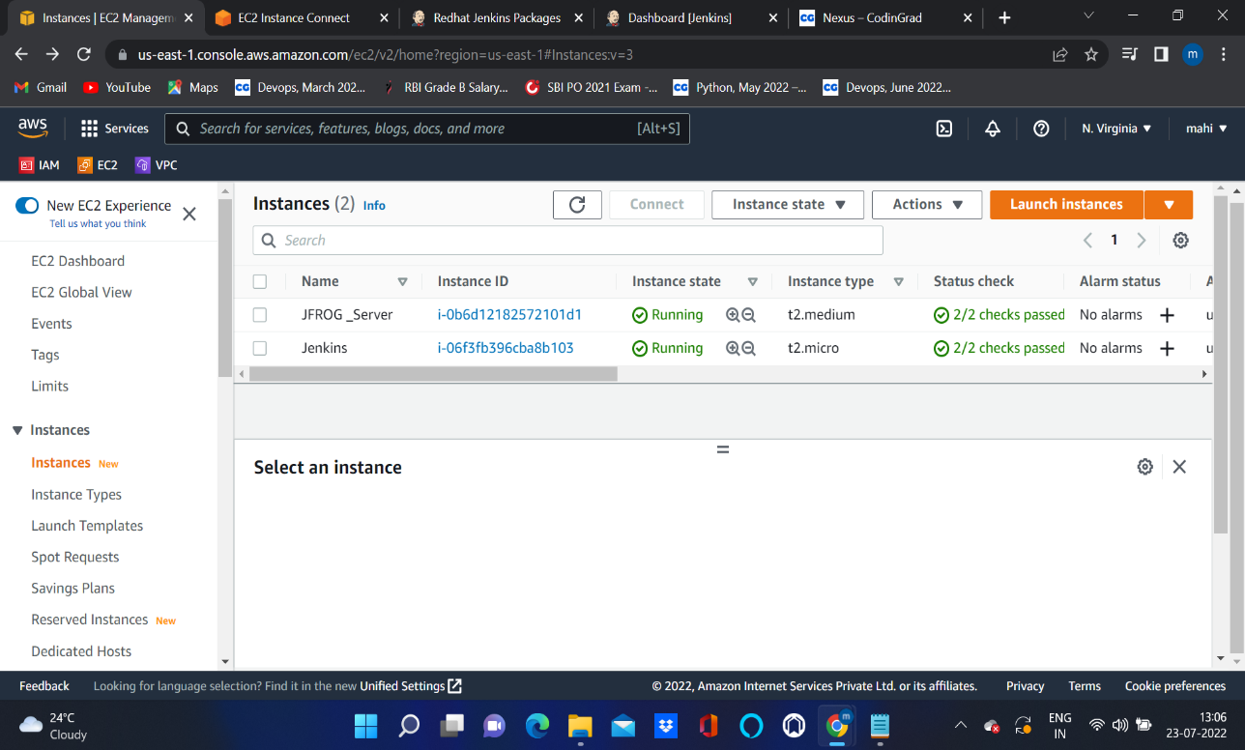

1. After configuration of Jenkins copy public ip of server and paste it into new tab (publicip:8080)

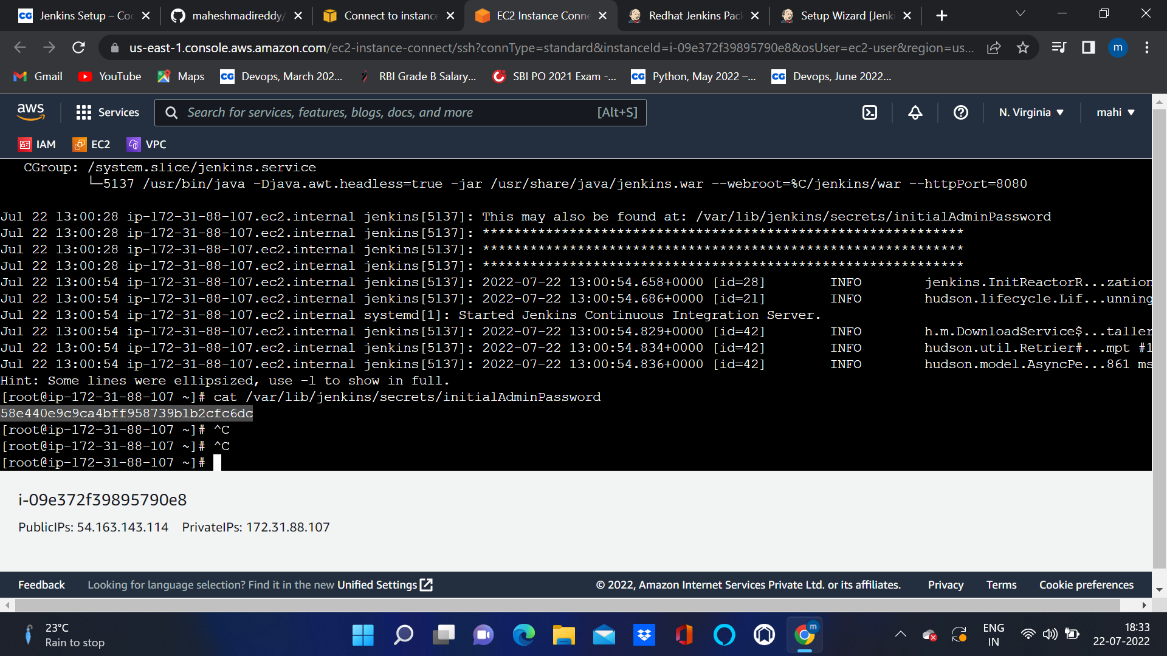

1. Install plugins
2. Give username and password and login to Jenkins dashboard
3. First we have to install artifactory plugin
4. Go to manage Jenkins and install without restart
5. Configure system and provide artifactory credentials
6. Create a maven job.

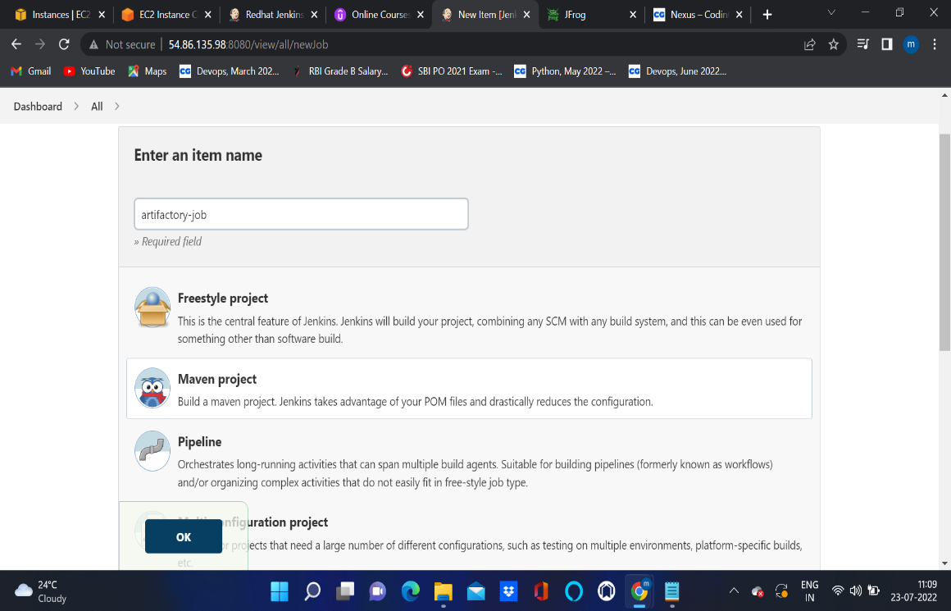

1. Give github repo url: <https://github.com/yankils/hello-world.git>
2. In build we have to give goals like clean install
3. In post build actions we have to select deploy artifacts to artifactory.
4. Specify Artifactory server url
5. Select Build now

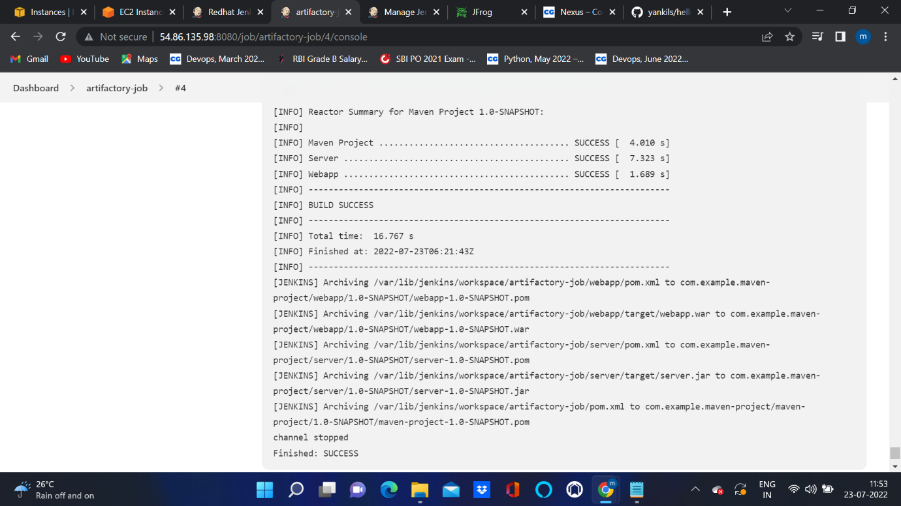

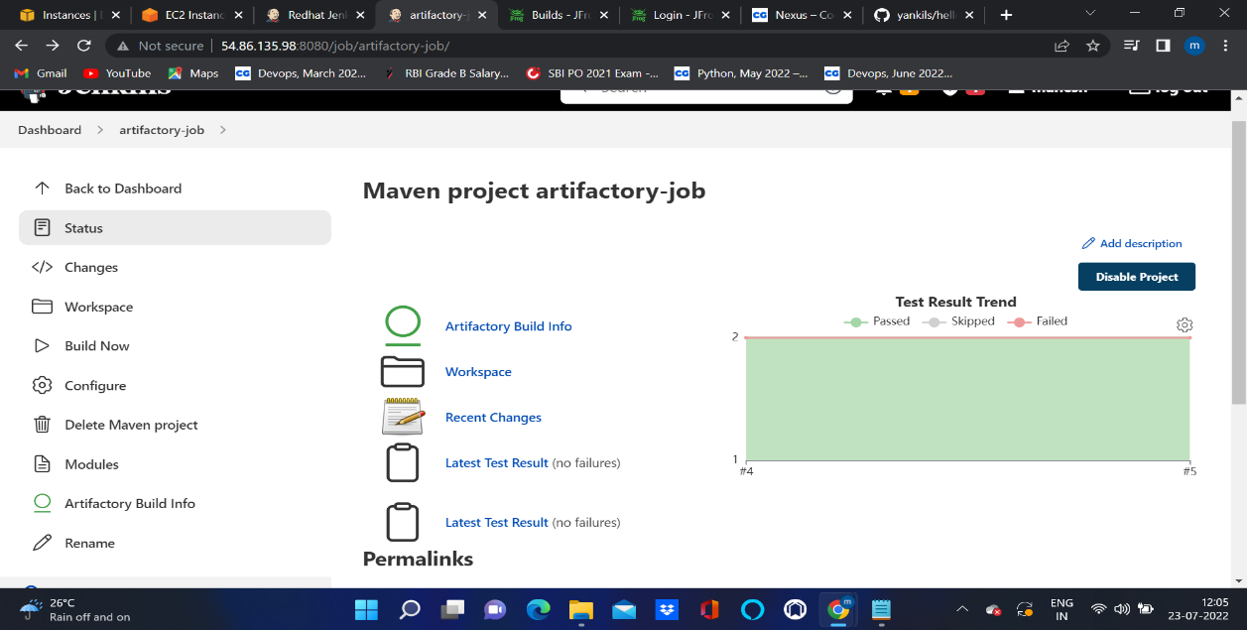

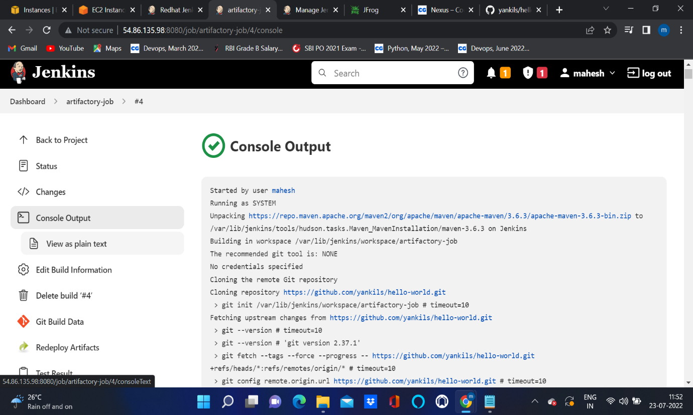

1. Go to Artifactory server and check build is deployed are not.

